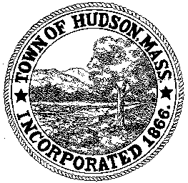

CONSERVATION COMMISSION
78 Main Street, Hudson, MA 01749
(978) 562-2020

Paul Byrne, Chairman W. Minot Wood, Vice Chairman David Esteves, Member

Terrence Joyce, Member Leif Longtine, Member Joseph Rodrigues, Member Al Tashian, Member

Meeting Agenda
June 17, 2010 7:00 P.M.

- Preliminaries
  - Open Meeting
  - Roll Call
  - Additions to agenda: request for extension 190-534

2.0 Hearings and Appointments
2.1 RDA 396
Applicant: Cidalia Luz
Location: 268 River Road
Project Description

2.2 Neil Fossile

2.3 DEP 190-
Applicant: Glynn Velardo
Location: 54 Lakeside Avenue
Project Description: Repair an existing wall, removal of a wood patio and tree stumps. A new stone patio and retaining wall will be built.

2.4 DEP 190-
Applicant: Wal-Mart Stores, Inc.
Location: 280 Washington Street
Project Description: Remove grass from end capped islands within the parking field to replace them with mulch, construction of an 18” concrete strip adjacent to the northern building face, a proposed drain connection to an existing storm manhole at the north side of the existing building, and a proposed 20’ +/- extension of the guide rail and fence into the buffer to meet the existing guide rail and fence.

2.5 DEP 190-547
Sign Order of Conditions

2.6 Legal Opinion on Conservation Restriction

3.0 General Business
3.1 Old Business
3.2 New Business

4.0 Adjournment

